Berlin Robolabs

Project description

Robotics Control System

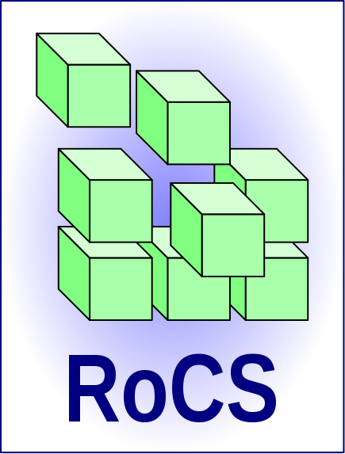

Revision 0.0.1
Date: 16.10.15

Contents
1Project in brief 3
2Technical Component description 4
1Message queue server (rocsmq-server) 4
2Message queue clients 4
1I²C Bus layer (rocsmq-i2cbus) 4
2CAN-Bus layer (rocsmq-canbus) 4
3GPIO layer (rocsmq-gpio) 4
4Serial layer (rocsmq-tty) 4
5Universal scriptable client (rocsmq-luaclient) 4
3Structural Overview 5
1Message flow 5
5Handling instructions 7
1Prerequisities 7
2Building the system 8
3Running the example 8
4Creating your own agents 8

Project in brief
The robotics control system, short RoCS is an open source project which aims to provide a scalable software infrastructure for robotics development. It is basically a set of Linux daemons which have the ability to communicate via a central message system.
Those messages are described by a message type and a tail containing the message data. Message data can be plain text or json structures.
Each client component is able to send messages to a queing infrastructure called rocsmq. Rocsmq is a centralized server, similar to a chat server. A client who connects it can give it a name and a filter. While the name is just for logging issues, the filter serves as a information delimiter. The server only sends messages to a client if the message type matches the filter.
All components are written in C. There is an universal logics client with the ability of tcl scripting which can be used to easily build a new component into the infratructure.

Technical Component description

Message queue server (rocsmq-server)

Message queue clients
The rocsmq client is basically a set of C functions which enable the developer to connect the message queue and send or receive messages.
Additionally, there are functions for accessing dynamic linked lists as well as a function to daemonize the client process.
There is a set of standard clients which are already delivered as complete software.

I²C Bus layer (rocsmq-i2cbus)

CAN-Bus layer (rocsmq-canbus)

GPIO layer (rocsmq-gpio)

Serial layer (rocsmq-tty)

Universal scriptable client (rocsmq-luaclient)

Structural Overview

Message flow

Raw data
Environmental
information
Goal
information
Control data
Hardware-Layer
Sensor-Interpreter
Logic
Action-Planner

Install instructions

Prerequisities
You will need the following libraries to build rocs.
- Json-c
- libtcl
- libb64
- libssl
- opencv
- liblua
- sphinx/pocketsphinx
- espeak
In debian based systems you can install them using the command
apt-get install libb64-dev libjson-c-dev tcl-dev tk-dev liblua5.1-dev lua5.1 lua-json libcdb-dev libespeak-dev pocketsphinx libpocketsphinx-dev libi2c-dev i2c-tools libopencv-dev libssl-dev libsphinxbase-dev

In other systems, refer to your package management system..
Note: On debian wheezy, there is no libb64 or libjson-c so you may have to compile it on your own if you use Raspbian or Bananian.

Addittionally, you will need some tools to build it.
apt-get install build-essential cmake

You will probably also need to rebuild sphinx. Clone sphinxbase and pocketsphinx beca use debian pocketsphinx is a bit outdated..
git clone https://github.com/cmusphinx/sphinxbase.git
git clone https://github.com/cmusphinx/pocketsphinx
apt-get install python-dec swig bison
cd sphinxbase
./configure
make
sudo make install
cd ..
cd pocketsphinx
./configure
make
sudo make install

I hope, that's all. Tell me if not. ;)

Building the system
To build the system, create a folder named build inside the rocs directory, change into this directory and run cmake to create the build system. After, build with make.
$ cd rocs
$ mkdir build
$ cd build
$ cmake ..
$ make
$ make install

Running the examples
There are two examples delivered. Test just tests some basic functions while SimpleRaspiConfig will work as a small robot.

Running the 'test' example

Running the 'SimpleRaspiConfig' example

Creating your own robot system

